

**ShipIT, An Interoffice Shipping Application**CS633 Software Quality, Testing and Security Management  
**Wireframes—Version 0.1**  
Term Project; Module 2 Deliverables  
Group #6  
Brian Calhoun  
Alicia Gallagher  
Steven Hoffman  
Eunjou Kim  
Carolina Torres  
January 24, 2017



# Wireframes

## Main Menu

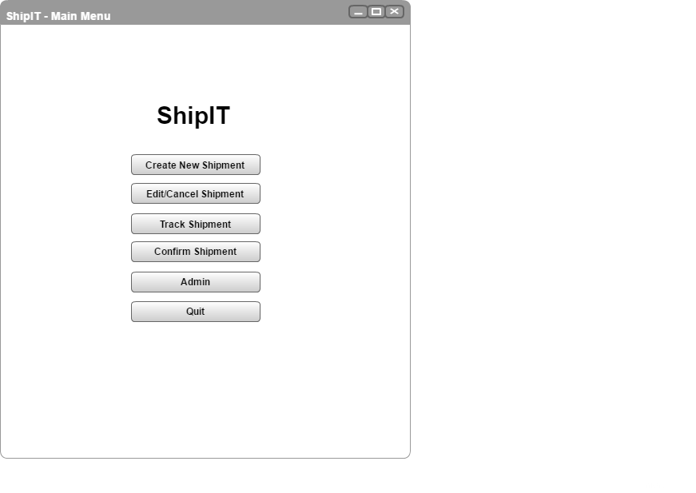

## Create Shipment

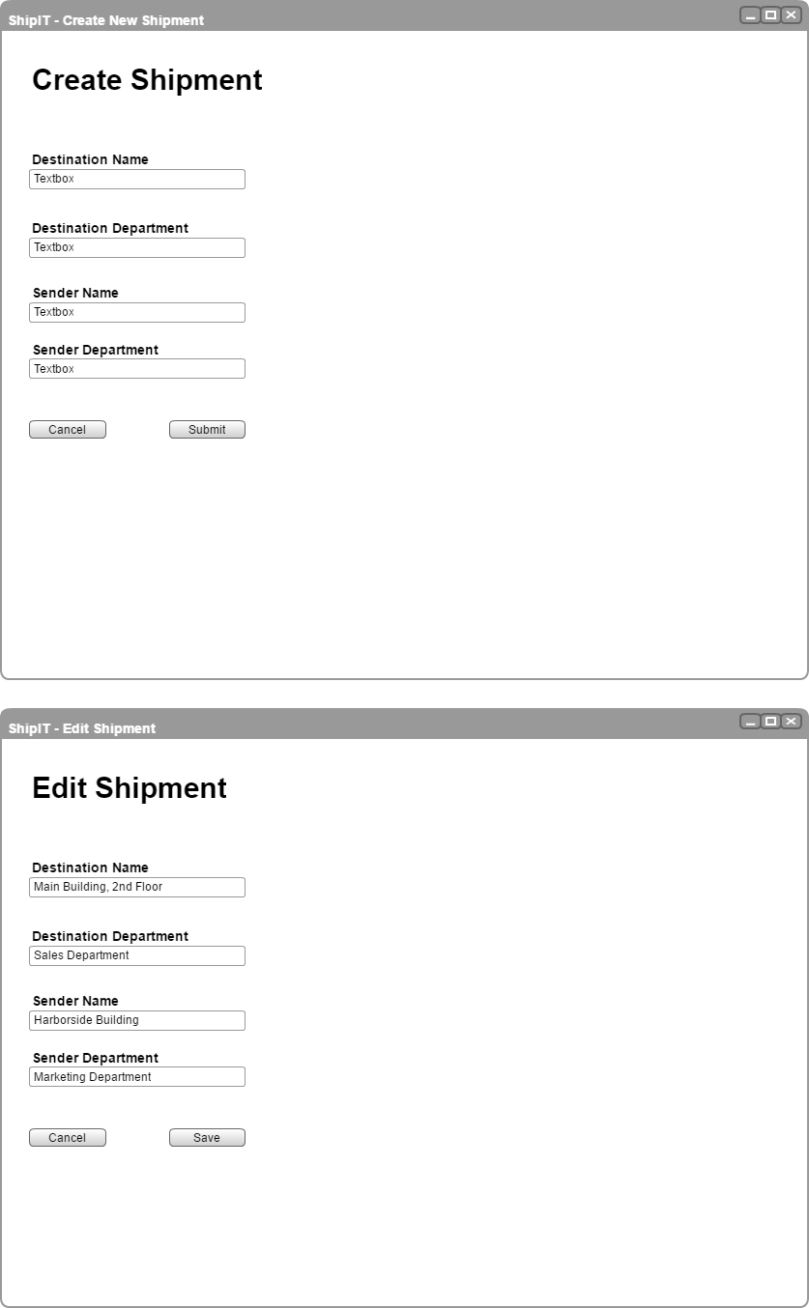

## Edit Shipment List

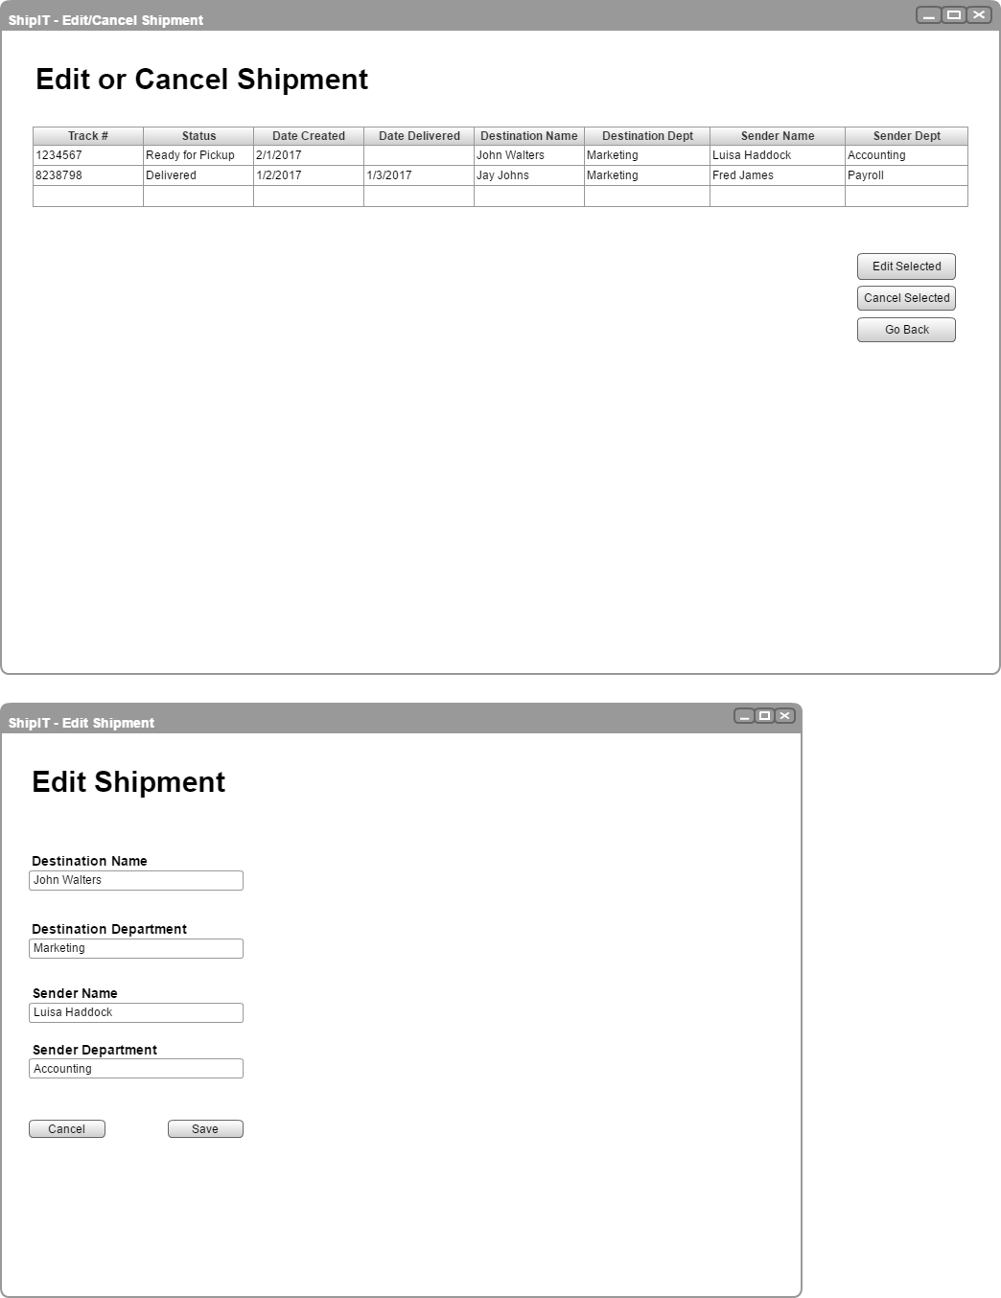

## Edit Shipment





## Track Shipment

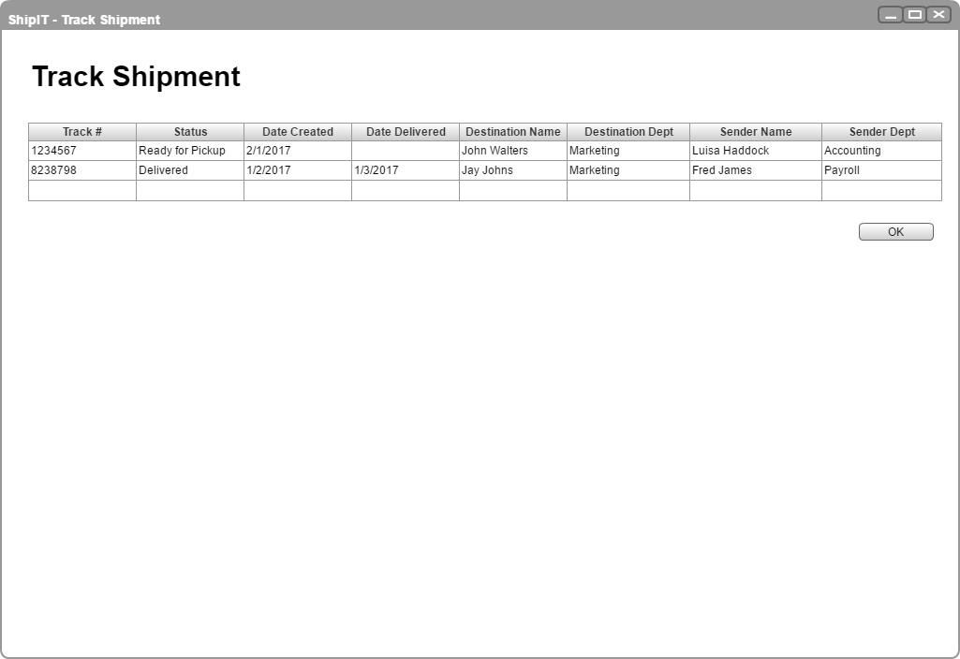

## Confirm Shipment

